Assignment 7-Database Design II

**Part 1: Create a database (1%)**From Assignment 6, **Part 3: Log the Blog Schema** where you were asked to create a database schema for a video games blog with multiple blog authors with **5 columns** for the authors table, and **5 columns** for the posts tables. In addition, you were asked to specify data types for each column and identify primary or foreign keys. Using this database schema, your task is to:

1. Create a database using a DDL command and specify the data type (auto- increment, primary key, VARCHAR(), INT() etc).

Creating database:



Creating tables:





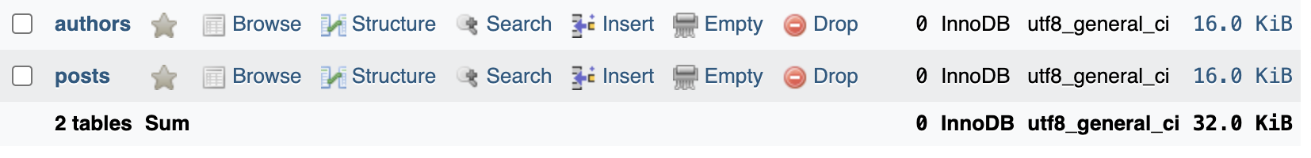

1. Write SQL statement to insert at least 3 records into each of your tables.

**Part 2: Table Creation (1%)**

1. Write a SQL statement to create a new table called “Comments” with at least 2 columns and specify the relationship between the tables as well as any constraints (i.e. primary key, foreign key, auto-increment)



1. Write a SQL statement to insert data into the “Comments” table. All rows must be filled with data.

**Part 3: Update and Delete (1%)**

1. Update the “comments” table by adding a new column to the “Comments" table called “comment_date” with appropriate datatype and fill in with data (at least 3).

B. Delete the first 2 rows from the Authors table and any corresponding data from the Posts table and Comments table (Hint: Use a JOIN).

Authors Table

Posts Table

